EndDrawer in Listview

Exercise #3

Flutter Developer Bootcamp

# **Purpose**

This exercise demonstrates how to implement a ListView with an end drawer in a Flutter application.

**Problem**

In the provided Exercise You need to create as follows:

Create a Flutter app featuring a ListView with an end drawer. It utilizes MaterialApp as the root widget, with a Scaffold containing an AppBar and a body comprising a ListView. The endDrawer adds a panel with options like "Account," "Settings," and "Help." Additionally, a custom ListView builder creates a scrollable list of items with tap functionality. Overall, the code demonstrates the integration of a ListView with an end drawer for improved navigation and user interaction in a Flutter application.

**How to Solve**

1. Checkout the exercise from Git Repo:

git clone -b <user-branch> <repo-URL>

2. Open the root folder inside VS Code

3. To build the app click the run option in the main method{}

4. Provides a basic layout structure for the home screen, including an AppBar and body.

5. Displays a toolbar at the top of the app with a specified title.

6. Contains the main content of the home screen, represented by an instance of the MyListView widget.

7. Specifies an end drawer panel that can be swiped in from the right side of the screen.

8. Creates a side panel for navigation options, containing a ListView of widgets.

9. Provides a header for the drawer panel with a specified text and background color.

10.Represent individual items in the drawer menu, each containing an icon, title, and onTap callback function.

11. A StatelessWidget representing the ListView displayed in the body of the home screen.

12.Generates a scrollable list of items dynamically based on itemCount and itemBuilder properties.

13.Each ListTile in the ListView has an onTap callback function for handling taps on the item, currently placeholders with no specific functionality.

14. Go To File: <specific-file-with-navigation-method> à <method-name>, implement your logic.

**You will Achieve**

When you complete this Exercise you will learn the following:

* Implementation of a Flutter app with a ListView and an end drawer.
* The ListView displays a list of items, each represented by a ListTile.
* The end drawer contains navigation options such as Account, Settings, and Help.
* Tapping on items in the ListView or drawer is handled with placeholder callbacks.

**Included Widgets and Imports:**

* **import 'package:flutter/material.dart';:** Imports the Flutter Material package for UI components.
* **void main() => runApp(MyApp());:** Entry point of the Flutter application.
* **MyApp**: A StatelessWidget representing the entire application.
* **MaterialApp:** Configures the app with title and home screen.
* **Scaffold:** Provides a basic layout structure for the home screen.
* **AppBar:** Displays a toolbar with a specified title.
* **MyListView:** A StatelessWidget representing the ListView displayed in the body.
* **ListView.builder:** Generates a scrollable list of items dynamically.
* **Drawer:** Creates a side panel for navigation options.
* **DrawerHeader:** Provides a header for the drawer panel.
* **ListTile:** Represents individual items in the ListView and drawer.
* **Icons:** Icon widgets used within the ListTile widgets.
* **Text:** Displays text within the AppBar, DrawerHeader, and ListTiles.
* **EdgeInsets:** Defines padding for the ListView.

# **Screenshots**

## **Expected output(End Drawer in Listview)**

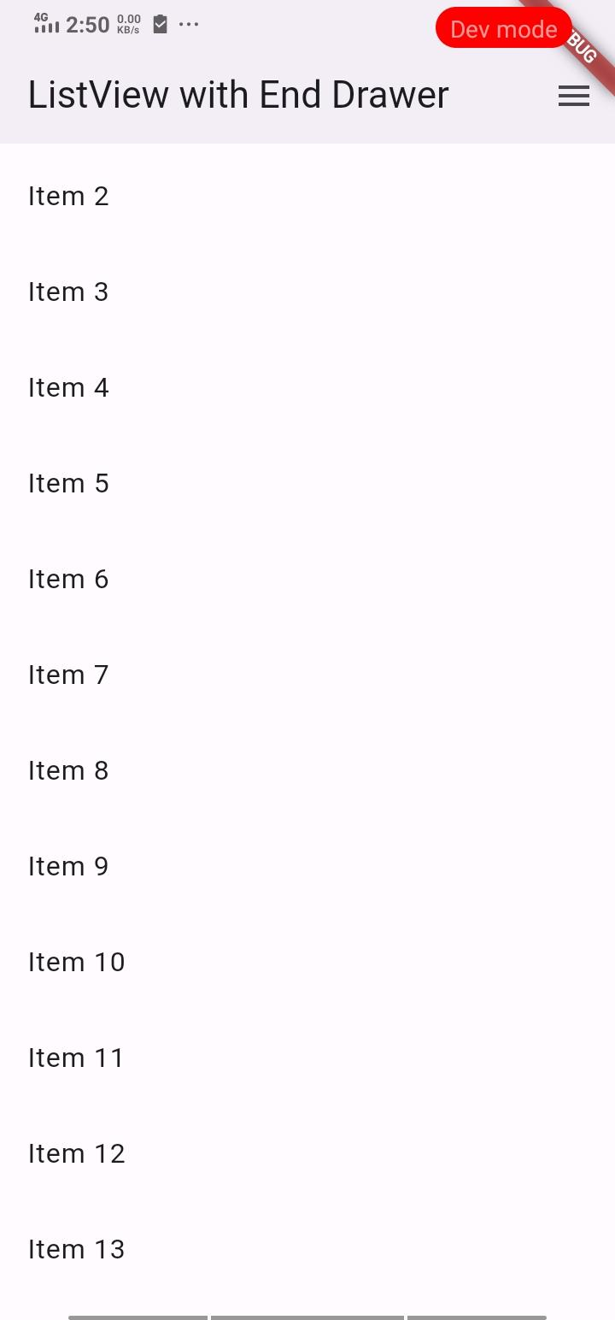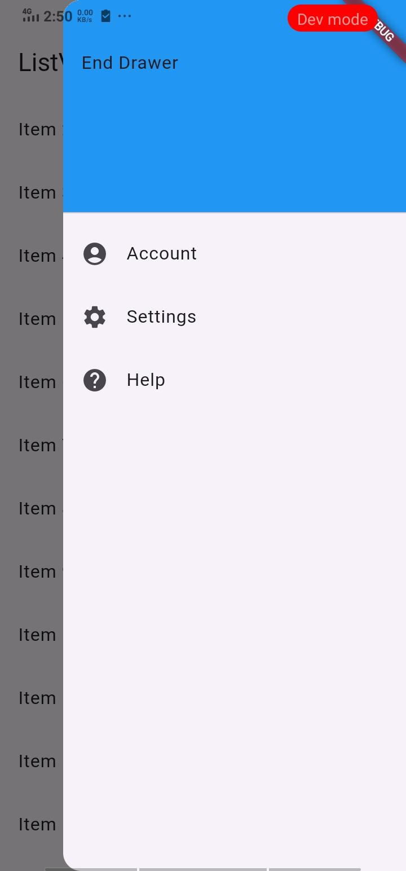

# **How to submit your Exercise**

Push your project back to the same git branch using command:

<command name>

# **Happy Coding!**